16 December 2009

Invention, Entrepreneurship and Prosperity: The Dutch Golden Age

Thijs ten Raa, Tilburg University
Pierre Mohnen, Maastricht University
Jan Luiten van Zanden and Bas van Leeuwen, Utrecht University

Abstract. The Dutch 16-17th centuries were a period of unprecedented economic prosperity. Since the Dutch economy was and is very small, an important source of growth was bound to be international trade. In this paper we argue that the contributions of entrepreneurship to innovation transcend the standard categories of the creation of new products and processes. Entrepreneurship also creates new modes of trade. The Dutch were the globalization pioneers avant la lettre. The same considerations apply to the later decline of the Dutch economy. The rise and decline of the Dutch Republic are well explained by a combination of the traditional Total Factor Productivity (TFP) driver, innovations, and two facets of trade, namely openness and entrepreneurship.
1. Introduction

Modern economic growth was initiated by the Dutch Republic in the 16th century. The Dutch Golden Age is basically the 17th century. The early Golden Age is the period 1590-1648 (the Year of Independence from Spain), a period of unprecedented innovation and prosperity, according to Israel (1998), who also notes that the early Golden Age was followed by a marked slackening, and after 1672 (the Year of Disaster, the French-English invasion) stagnation, which persisted until the middle of the eighteenth century. Israel (1998) dates the end of the Golden Age at 1702 (the death of William III, Stadholder of the Republic and King of England), although England had already taken over world leadership. In this paper we trace the performance of the Dutch economy from well before the Golden Age (1540) to well after (1807), which facilitates a better understanding of this fascinating era, both in terms of its timing and the causes of the rise and decline. We employ the standard economic performance measure, namely Total Factor Productivity (TFP), and consider its traditional driver, technology, or, more precisely product and process innovations. However, because the Dutch economy was (and still is) extremely open, we must factor in the role of trade in TFP.

Recently ten Raa and Mohnen (2002) have shown that for an international price-taking economy, TFP comprises not only the standard Solow residual (the difference between output and input growth, which measures product and process improvements), but also a terms-of-trade effect. Their analysis is apt for a price-taking economy with competitive imports (like the Canadian economy they investigated), but the Dutch Republic was an economy that not only adjusted to international price changes, but opened entire new lines of trade, backed by the invention of capital share markets and the exercise of monopoly power in establishing new trade relations. In other words, instead of a neoclassical microeconomic analysis, here we employ a more direct, reduced form, approach to the measurement and explanation of the economy’s performance.

In this analysis, we make extensive use of a data base recently developed by van Leeuwen and van Zanden (2009), covering factor inputs, industry outputs, and trade. These data cover the Dutch Republic’s most important province, Holland, where the Golden Age was pregnant. The data base itself is also of interest because there is no earlier comprehensive system of economic accounts. Several studies analyze historical (industrial) output data econometrically, especially for England (Crafts, 1995), but these cover only the post-1700 period. As far as we know, our paper is the first econometric analysis of an older economy.

2. The rise and decline of Holland’s economy

Between 1540 and 1807, Holland’s economy expanded and contracted quite spectacularly. Figure 1 shows the paths of both output and population growth.
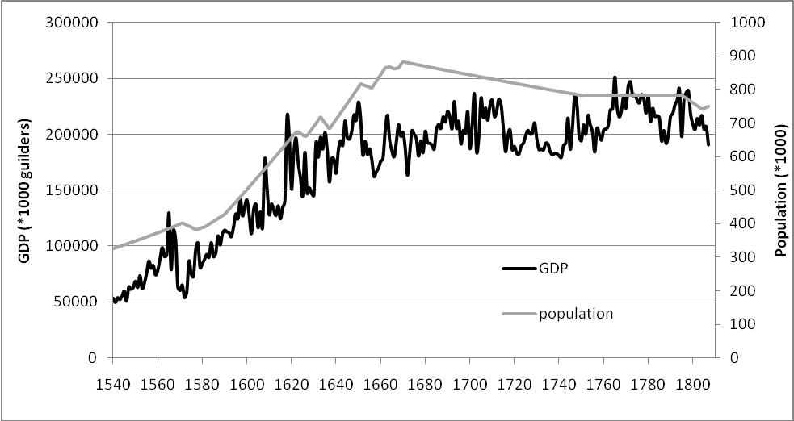
Figure 1: Output and population

During this period, GDP is initially flat, then climbs steeply (1570-1650), and finally is flat again. Meanwhile, Holland’s population grew until 1670 and then contracted until 1750. This population contraction absorbed the decline in output. At this time, of course, there was no ‘welfare state,’ and people had to chase jobs in order to survive. Thus, population traced output. When Holland’s economy grew, it attracted people, and when it declined, it repulsed them. This labor market flexibility tempered the rise and decline of the economy on a per worker basis. Holland’s capital market was also flexible. Success attracted foreign investment, and failure induced capitalists to invest abroad. Since TFP is essentially output per unit of factor input, an aggregate of labor, physical, and human capital, as well as land, its development was more tempered, and it has been argued that Holland’s economy continued to perform well after the Golden Age (van Leeuwen and van Zanden, 2009). However, as shown in Figure 2, TFP takes a hump-shaped pattern. (The construction will be explained in the next section.)

Figure 2: TFP from 1540 (normalized to 100) to 1807

Figures 1 and particularly 2 confirm Israel’s (1998) distinction between the early Golden Age and the later Golden Age. In the early Golden Age, the economy was poised for growth, all signals were on green: GDP, population, and TFP. In the later Golden Age, TFP recovered from the early 1650s crash, but only because Holland’s population was much reduced.

3. Total Factor Productivity

Labor, L, capital, K, human capital, H, and arable land, A, produce output, Y, according to a Cobb-Douglas function. Following van Leeuwen and van Zanden’s (2009) analysis of value shares, the input elasticities are 0.4 for labor, 0.3 for capital, 0.2 for human capital, and 0.1 for land. The sum of these elasticities is the returns-to-scale elasticity; here it is 1, which corresponds to constant returns to scale. It follows that the relation between the inputs and output is given by Y = TL^{.4}K^{.3}H^{.2}A^{.1}, where multiplicative factor, T, measures the level of output as a function of the level of input. Variable T therefore represents TFP and is employed to measure the performance of the economy. This is given by the input and output data according to T = Y/L^{.4}K^{.3}H^{.2}A^{.1}. Because we want to understand the pattern of this variable over a long period, including the Golden Age, we also must investigate technology and trade related explanations.

Product and process innovations are considered to be standard drivers of TFP, usually measured by numbers of patents. The patents granted in the Netherlands (The General State and the various provinces) are reported in Doorman (1940), and we use these data for our analysis here. However, because we measure the level of TFP rather than its growth rate, we must construct a patent stock, P. In order to do this, we start from an initial value of 0 (which seems reasonable because our time series begin as early as 1540, while the first patent granted was only in 1559) and use a 25% depreciation rate, following Pakes and Schankerman (1984).

4. Trade

Because the Dutch economy was driven by trade, which, in turn, impacts productivity, we must include trade in our performance analysis. The rise of the Republic was driven by entrepreneurship in overseas trading. The Dutch explored new routes with different merchandise, beginning with the Baltic and following later with Spain-Portugal. When barred by political or logistical difficulties, the Dutch were creative in opening new modes of trade, such as the ‘long haul’ route to the Indies (primarily the East), which by-passed Spain. As such, the Dutch were the globalization pioneers avant la lettre. The same considerations apply to the later decline of the Dutch economy. Israel (1998) argues that, in the late 17th century, the Dutch showed noticeably less dynamism than the English and the French in opening up new strands of (Asian) commerce.

The traditional trade-based performance factor is openness, the ratio of trade (exports plus imports) to GDP. It is not our intent to diminish the import of openness, but we propose that trade entrepreneurship cannot be measured effectively by this factor. Whereas openness is about the volume of trade, entrepreneurship is about the spread of trade, particularly by new routes. These are different facets of the spatial distribution of trade. For our purposes here, we measure both openness and entrepreneurship.

For this analysis, we use Dutch shipping capacity data for five trade routes, the Sound (Baltic), the East-Indian Company VOC (Asia), the West-Indian Company WIC (Americas), the Rivers (Continental Europe), and an aggregate for the other routes, called Rest. We thus have aggregate data, x_{it}, where i = 1, ..., 5 are the five routes, and t indexes time, which we have scaled as fractions of GDP. Openness is measured by the volume of trade, O = x_{1t} + ... + x_{5t} = 5μ, where μ is the first moment or mean level of trade (as fraction of GDP). Entrepreneurship is measured by the spread or standard deviation of trade (the square root of the second, centered, moment): E = √{[(x_{1t} – μ)² + ... + (x_{5t} – μ)²]/5}.

Figure 3: Entrepreneurship from 1540 (normalized to 100) to 1807

The results shown in Figure 3, which plots entrepreneurship over time, lend support to Israel’s (1998) focus on economic dynamism as the driver of prosperity in the late 16th and the 17th century and its petering out in the late 17th century. Comparison of entrepreneurship (Figure 3) with TFP (Figure 2) is startling. Both graphs show a hump shape. Since TFP is the leading performance measure and entrepreneurship is an important driver of TFP, Figures 2 and 3 may be viewed as a description and at least part of the diagnosis of the Dutch Golden Age in economic terms.

In the next section we will substantiate these observations by an econometric analysis of TFP in terms of the traditional, technological variable, innovations, as well as the trade variables, openness and entreprneurship.

5. Performance analysis

Next, we regress TFP measure, T, on patent stock, P, openness, O, and entrepreneurship, E. Here, we use a log-linear specification so that the coefficients are elasticities. As shown in Table 1, all three variables are positive and highly significant.

Regressor | Coefficient | T-value | 95% Confidence interval
Patent stock | 0.030 | 5.59 | 0.019 | 0.041
Openness | 0.120 | 3.55 | 0.054 | 0.187
Entrepreneurship | 0.136 | 5.55 | 0.088 | 0.185
Constant term | 5.150 | 104.95 | 5.054 | 5.247
Table 1: Regression of TFP on innovation, openness and entrepreneurship

Table 1 also shows that the traditional driver of TFP, innovations, is found to have an elasticity of 0.03. The patent stock can be considered as an alternative to the R&D stock for measuring the stock of knowledge, when the purpose is to estimate an elasticity or rate of return. In the literature, the elasticity of output with respect to innovation is generally measured from the input side using an R&D stock, and this is reported around 0.08 (Hall, Mairesse and Mohnen, 2010). Our elasticity of TFP to the patent stock of 0.03 is smaller but not far off. We also can convert the elasticity to a rate of return by multiplying it by the ratio of the average output to the average patent stock (as implies ). This yields a marginal return on a patent of approximately half a million 1880 Florins, which represents roughly 0.2% of the GDP in Holland in 1880. As a rough comparison, today a patent often is assimilated to $1 billion of R&D, which represents approximately 0.1% of Holland’s GDP. Our return is bigger but, again, not far off. It is fascinating that, in the Golden Age, innovation had an impact of the same magnitude as it has in modern economies.

The standard trade measure, openness, has an elasticity of 0.12. This means that an increase in openness of 1% boosts growth by a one-eighth of a percentage point. This magnitude is slightly less than what Lewer and Van den Berg (2003) found for modern economies: elasticities of 0.43/0.15/0.22/0.21 for high/upper-middle/lower-middle/low income countries.

Our new variable, entrepreneurship, has strong impact; its elasticity is 0.14. This means that an increase in entrepreneurship of 1% boosts growth by one-seventh of a percentage point.

6. Lessons

The rise and decline of the Dutch Republic can be explained by a combination of the traditional TFP driver, innovations, and two facets of trade: openness and entrepreneurship. Economic decline may put pressure on research and development outlays and often intensifies calls for protection, but yielding to these pressures aggravates the problems. Instead, the better solution involves creating an economic climate that encourages entrepreneurship in the wide sense of not only facilitating new products and processes but also new lines of trade.

References

Crafts, N.F.R. (1995), “Exogenous or Endogenous Growth? The Industrial Revolution Reconsidered,” Journal of Economic History 55, 4, 745-72.

Doorman, G. (1940), Octrooien voor Uitvindingen in de Nederlanden uit de 16e-18e Eeuw. ‘s-Gravenhage.

Gerschenkron, A. (1947), “The Soviet Indices of Industrial Production,” Review of Economics and Statistics 29, 3, 217–226.

Hall, B., J. Mairesse and P. Mohnen (2010), “Measuring the returns to R&D,” in B. Hall and N. Rosenberg (eds.), Handbook of the Economics of Innovation, Elsevier.

Israel, J. (1998), The Dutch Republic: Its Rise, Greatness, and Fall 1477-1806, Oxford University Press, Oxford.

Lewer, J. and H. Van den Berg (2003), “How Large is International Trade’s Effect on Economic Growth?” Journal of Economic Surveys 17, 3, 363-96.

Pakes, A. and M. Schankerman (1984), “The Rate of Obsolescence of Patents, Research Gestation Lags, and the Private Rate of Return to Research Resources,” in Z. Griliches (ed.), R&D, Patents and Productivity, University of Chicago Press, Chicago.

ten Raa, Th. and P. Mohnen (2002), “Neoclassical Growth Accounting and Frontier Analysis: A Synthesis,” Journal of Productivity Analysis 18, 2, 111-28.

van Leeuwen, B. and J. Luiten van Zanden (2009), “The Origins of ‘Modern Economic Growth’? Holland between 1347 and 1800,” working paper.

This author’s research was performed at Bar-Ilan University and NYU Polytechnic Institute and Stern School of Business. Benjamin de Vries (Bar-Ilan) and William Baumol and Charles Tapiero (NYU) offered constructive input and facilitated this project. Anne Noyes Saini (NYU) masterly edited the manuscript.
This follows van Leeuwen and van Zanden (2009), with human capital added. Labor is measured by total population. Capital stock is the sum of construction and shipbuilding capital stock. Land is the cultivated area, and human capital is the average years of education. Output is measured by GDP in constant prices, corrected for the Gerschenkron (1947) effect, by which the relative prices of fast growing sectors were declining compared with the prices of branches of industry that grew more slowly. Output and the four inputs have been normalized to 100 in 1540.
As we took the logs of the stock of patents, zeros prior to 1559 were set equal to 0.1. After 1559, hardly a year went by without at least one patent application.

